**OUTPUT SCREEN**

**#** First graphic user interface box to choose out of three operations

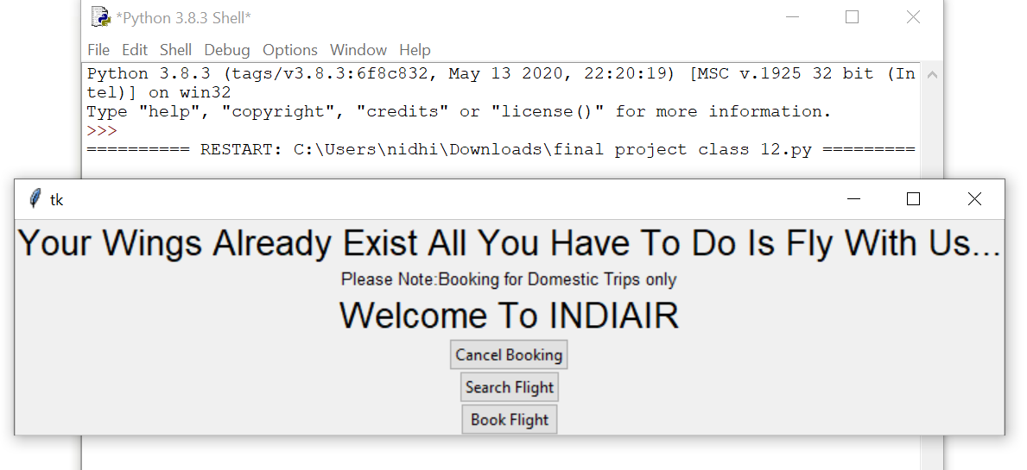

# performing search operation for availability of flights for a particular route

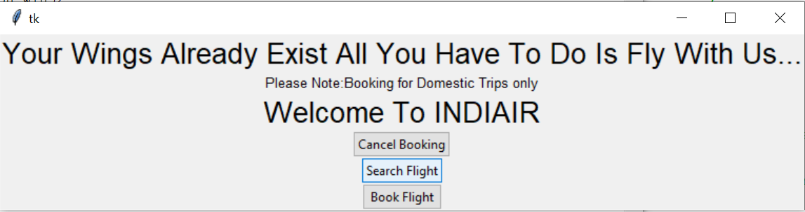

# inserting boarding and destination details for search operation box generated

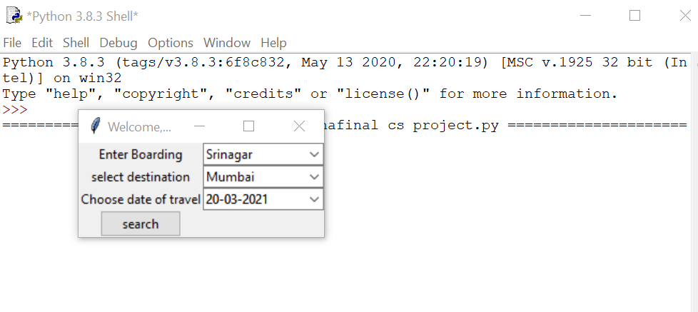

# message box for available flights

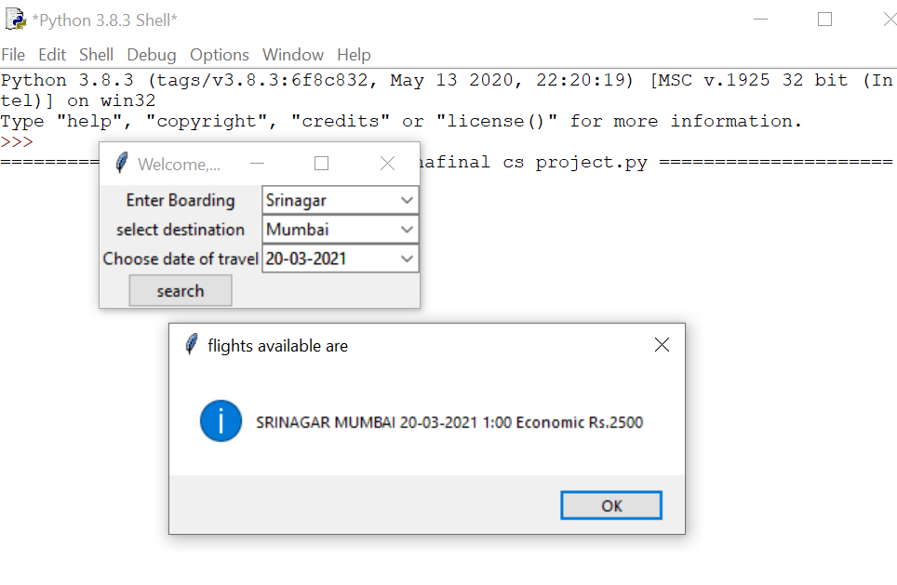

# box if details entered are routes we don’t provide services to

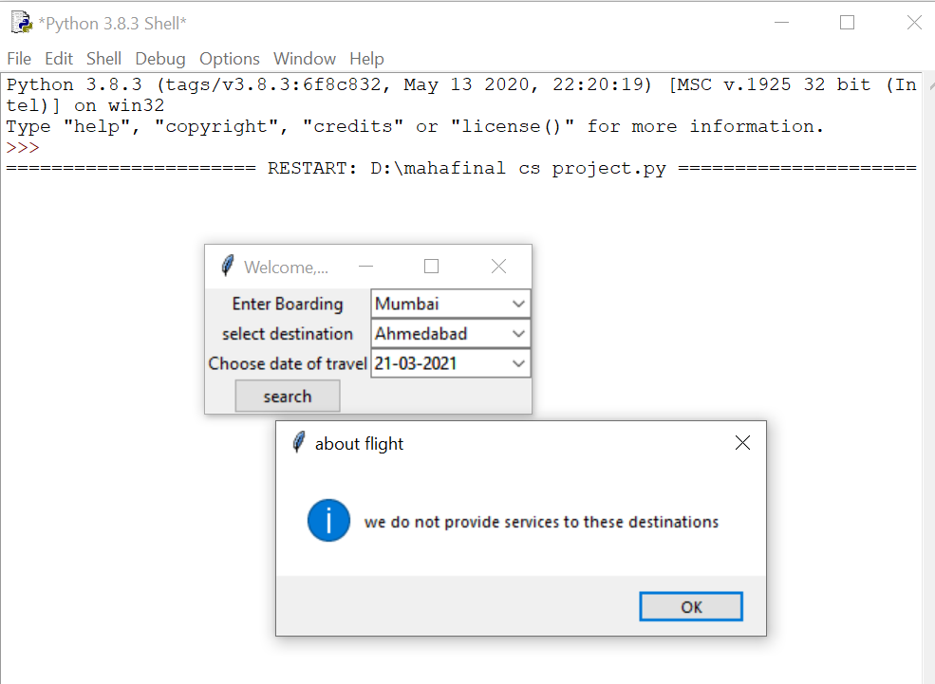

# performing booking operation

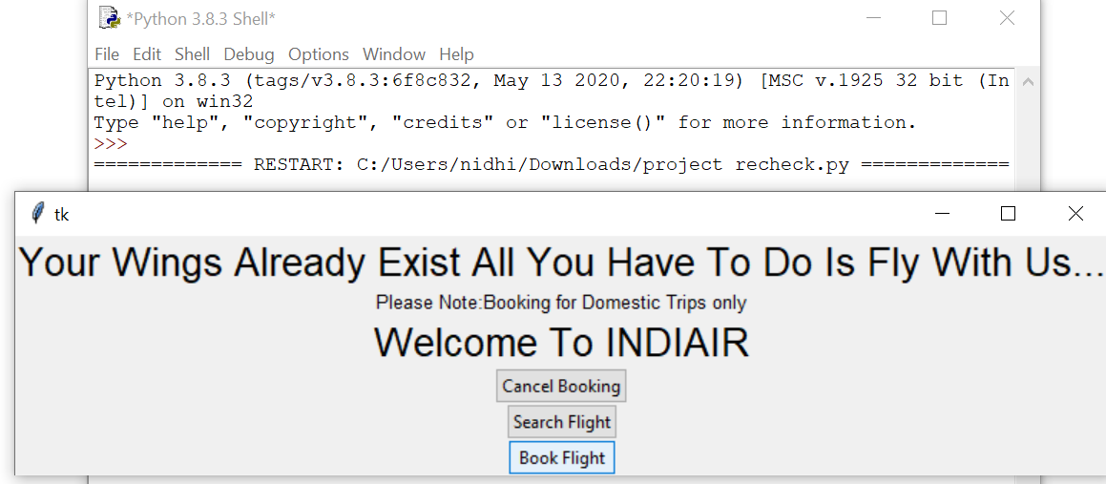

#generation of error box if the boarding and destination are the same city

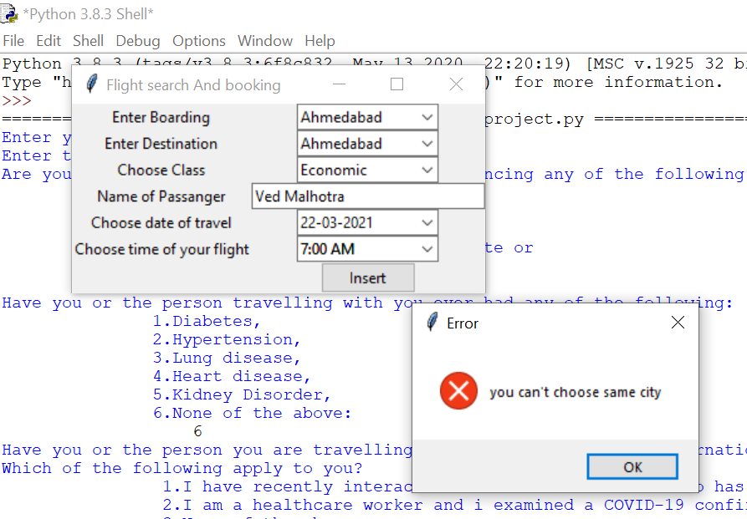

# error box generation if a field is left empty

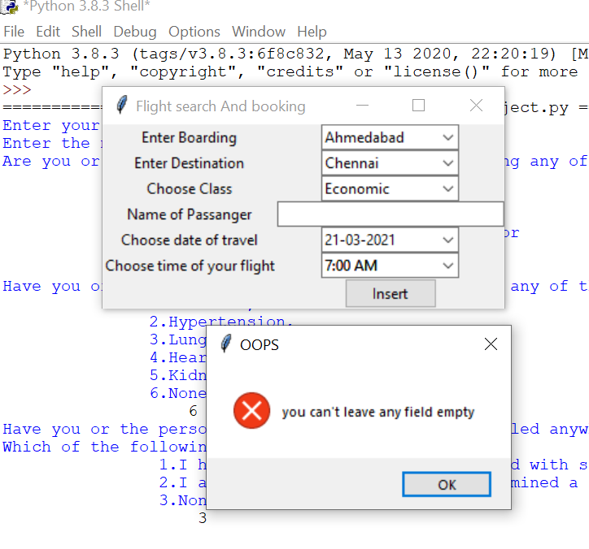

# if the traveller is suspected to be a covid carrier

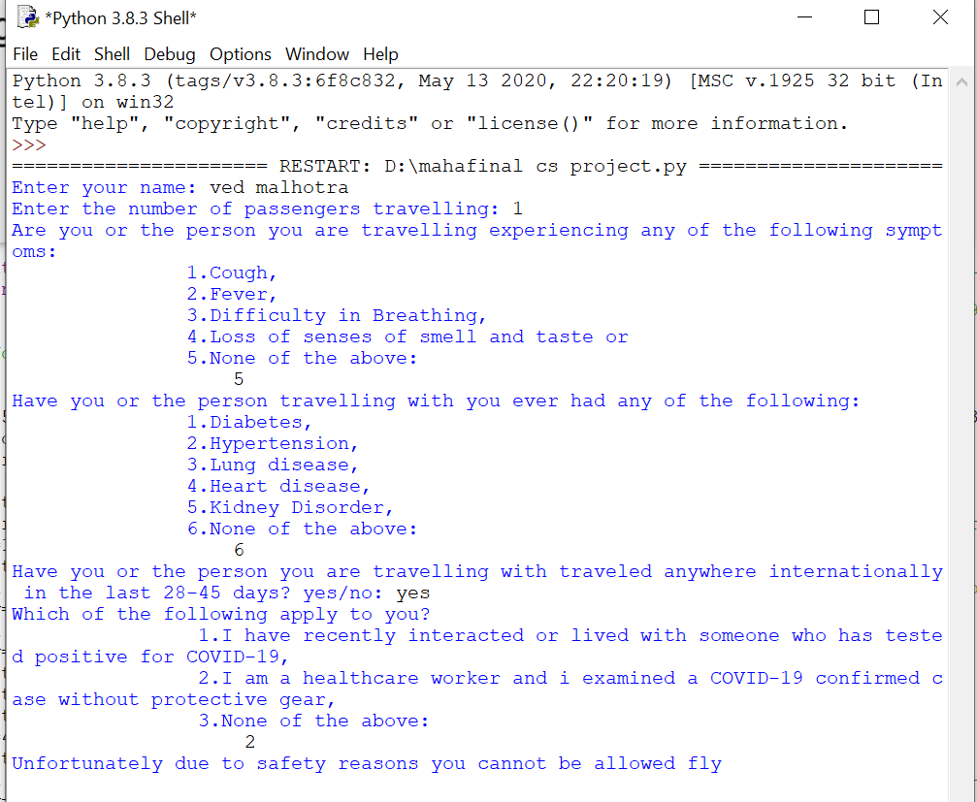

# booking tickets in economic class

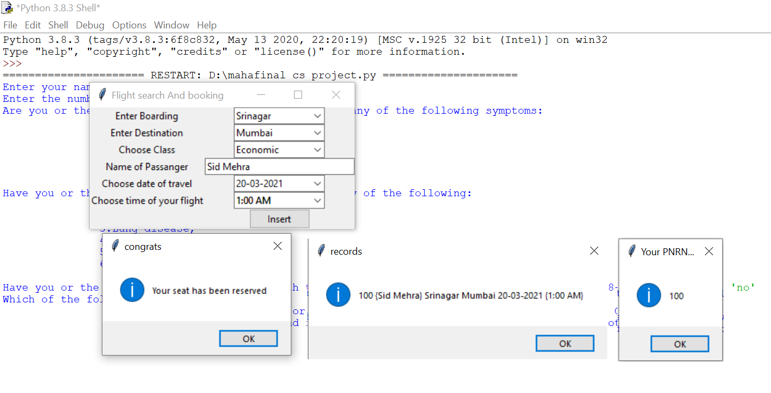

#performing cancel booking operation

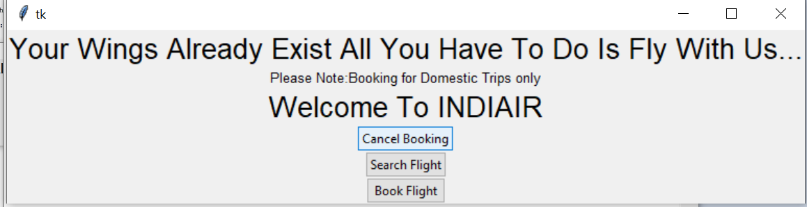

# cancelling reserved economic class tickets

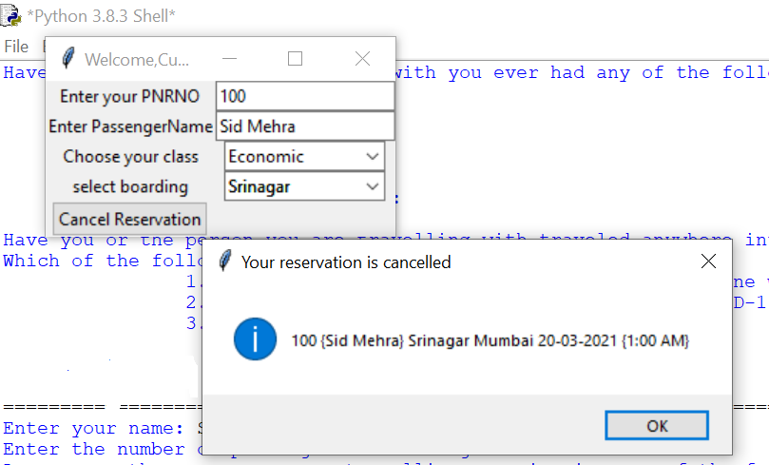

# booking tickets in business class

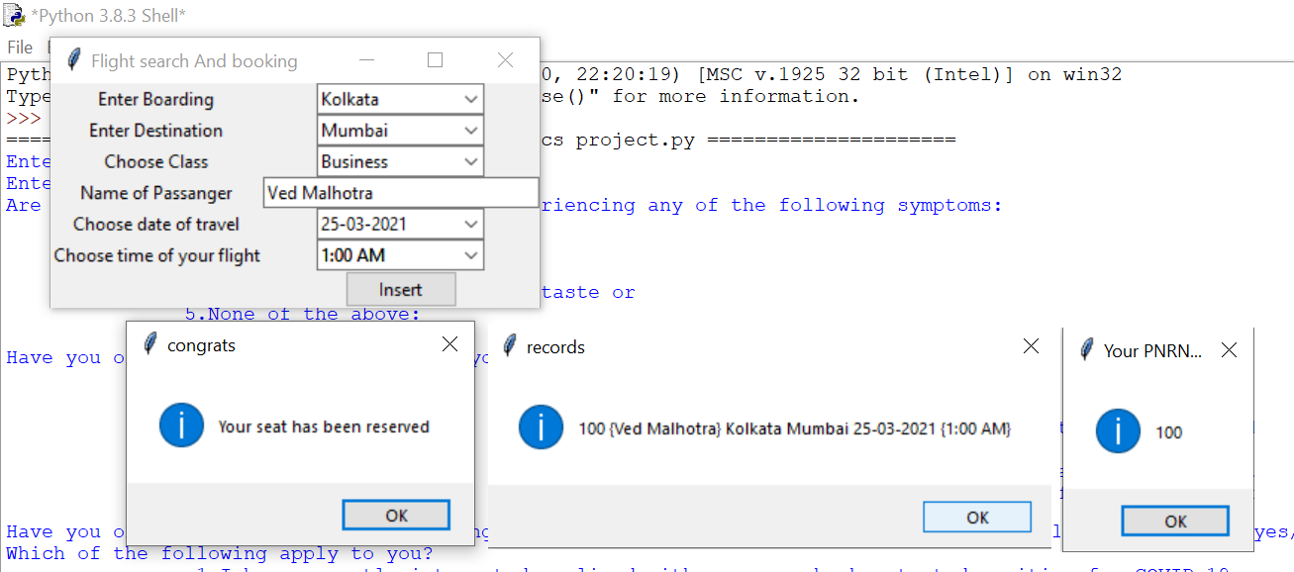

# cancelling a reserved seat in business class

